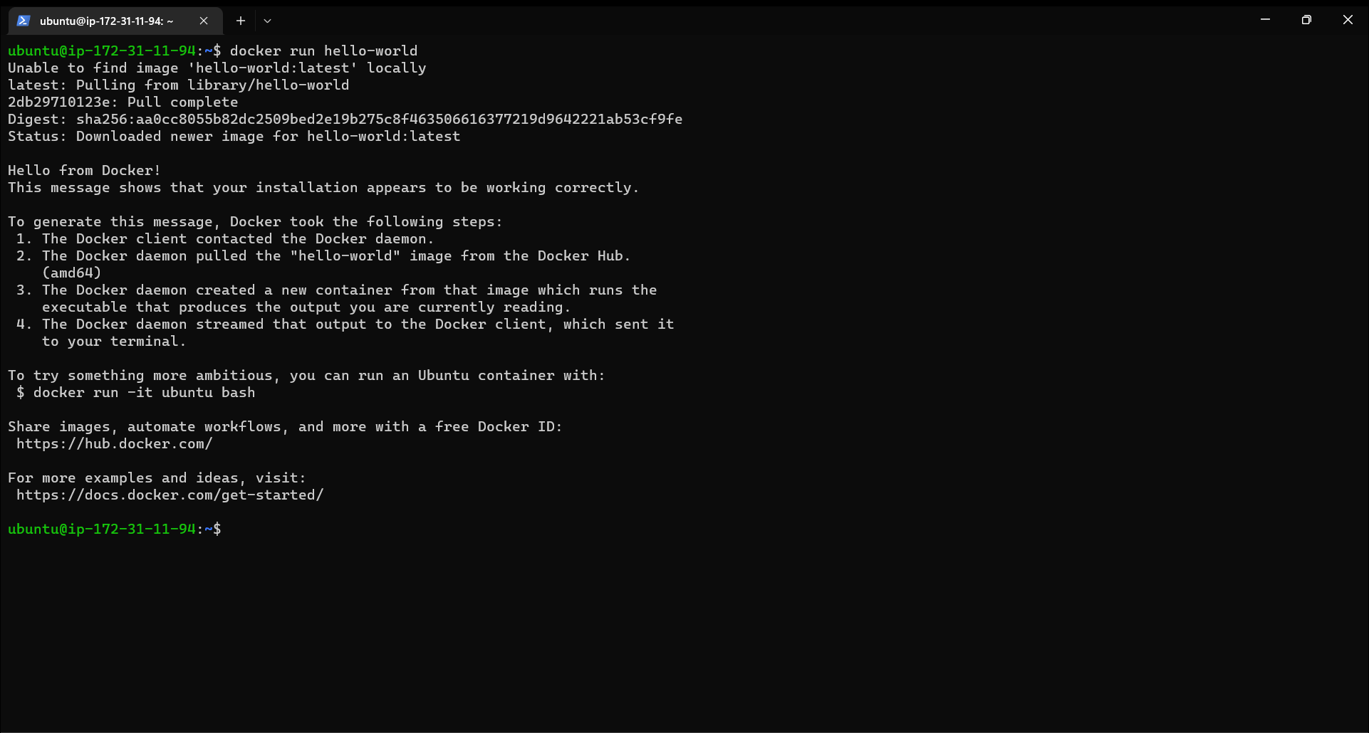

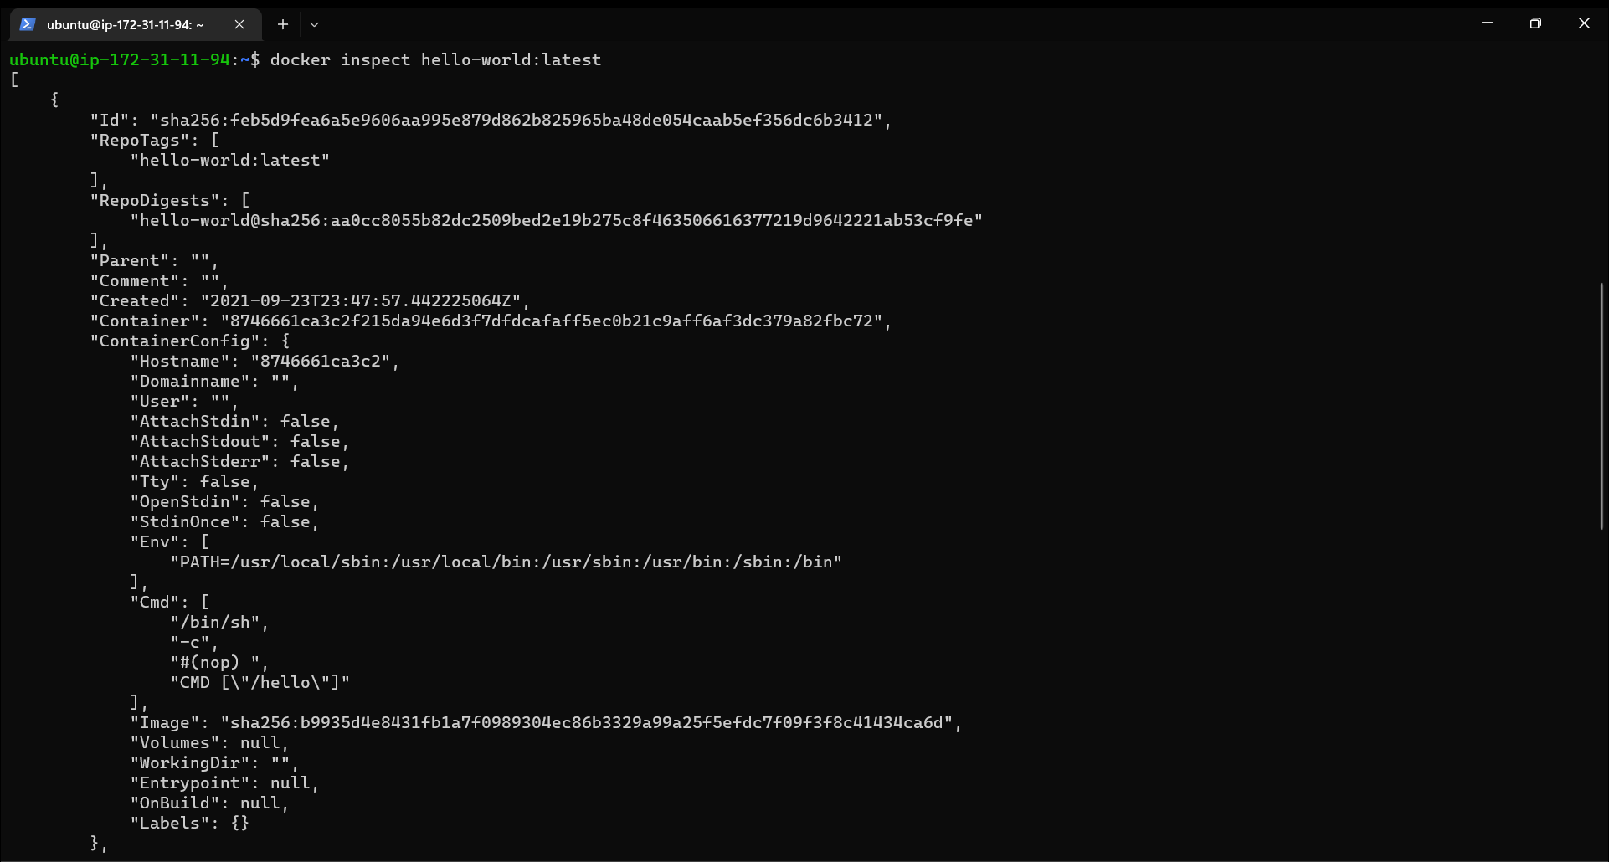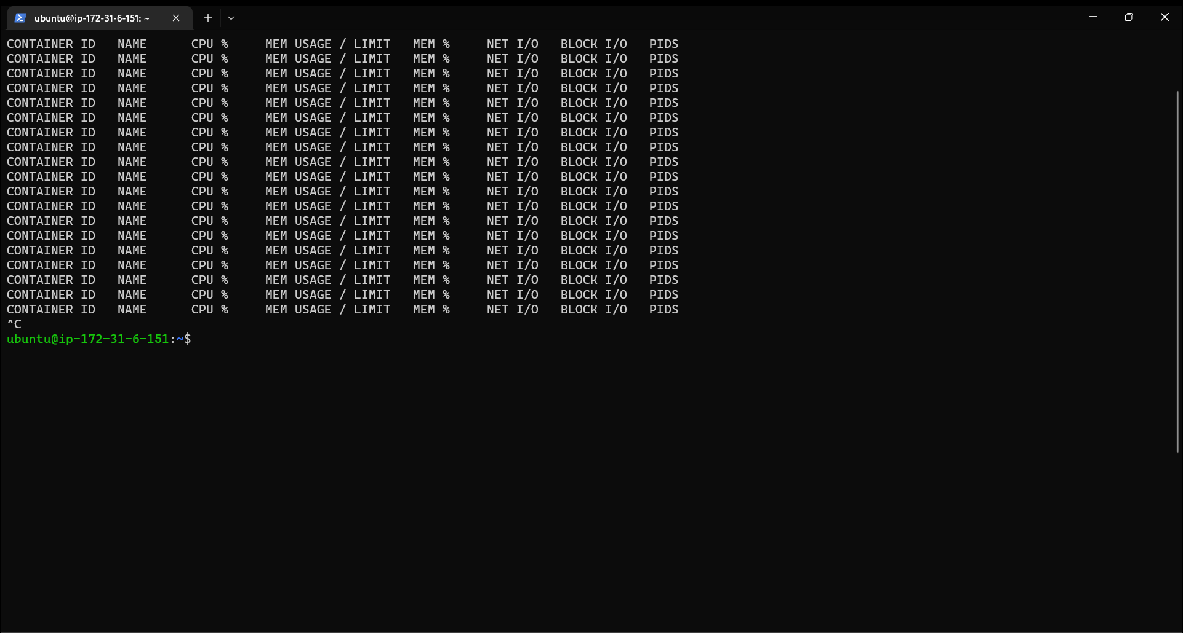

docker port command to list the port mappings for a container.

docker stats: command to view resource usage statistics for one or more containers.

docker top: command to view the processes running inside a container.

docker save: command to save an image to a tar archive.

docker load: command to load an image from a tar archive.